**Geotab Installation Instructions**

**Notices:**

**Devices and harnesses should have been sent out for this campaign. If you need a new Geotab device or harness, you can order a new one by going to** <https://install.assuredtelematics.com/penske/> **and clicking on the Order Device button.**

**If you have a device with a serial number that starts with G7, please do not install it. It will need to be replaced with a newer device with a serial number that starts with G8, G9, or GA.**

**Do not remove any non-Geotab devices you may find in the dash, they may be owned by the customer.**

**If you find another Geotab in the dash, please use the following instructions to check and see if it is Penske-owned and currently reporting.**

**Please go to** <https://install.assuredtelematics.com/penske/> **to check and see if it is a Penske device and if it is reporting. (Instructions below)**

Enter in the required information.

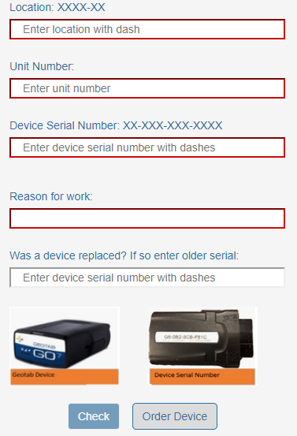

Once submitted, you will get one of the following screens:

The truck has a Penske device and is reporting, you can record the serial number in the job and mark it as completed:

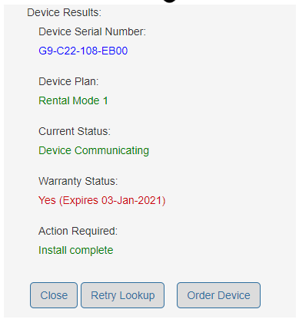

If you get any of the following screens, the device found is not a Penske-owned or not working. **Leave the device in the dash** and continue to install a new one:

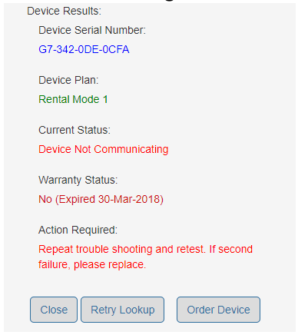 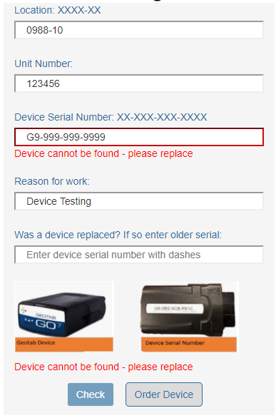

**Select Vehicle for Instructions:**

Freightliner Cascadia

Freightliner M2

Hino 100-Series

Hino 200-/300-Series

International LT

International 4300

International M607

Isuzu NPR

Volvo VNL Tractor

GMC Savana

Ford E350

Ford Transit

Dodge Promaster

**Freightliner Cascadia RP1226 Install (Preferred Installation)**

1. Make sure you have a Geotab and correct Harness in stock. (Please make sure you are not trying to use a Nexiq Bluetooth ELD Device)

Geotab Device: Nexiq Bluetooth ELD Devices:

Do not work on ELD

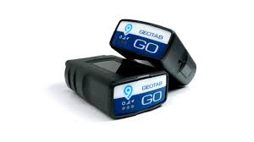 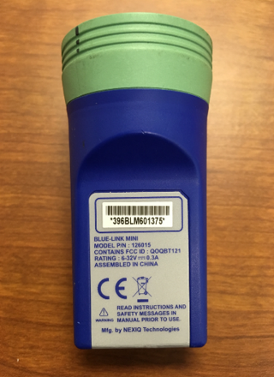 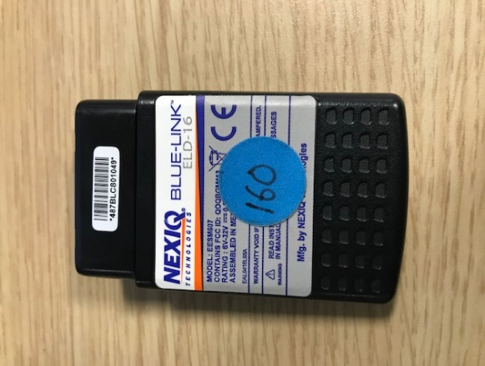

1. Locate Geotab Telematic Installation Area – Geotabs should be installed on the RP1226 port. The RP1226 connector will be located in one of two places: Middle of the dash or in the middle overhead bin (see pictures below). You may find other devices, including the Nexiq Bluetooth ELD Device if the vehicle requires driver logs (this is easily identifiable if the vehicle has a sticker on the exterior or interior identifying it is logging-capable). Leave all non-Geotab devices in place.

If you see a Geotab device installed, please use the directions on page 1 to verify if it is a Penske-owned device.

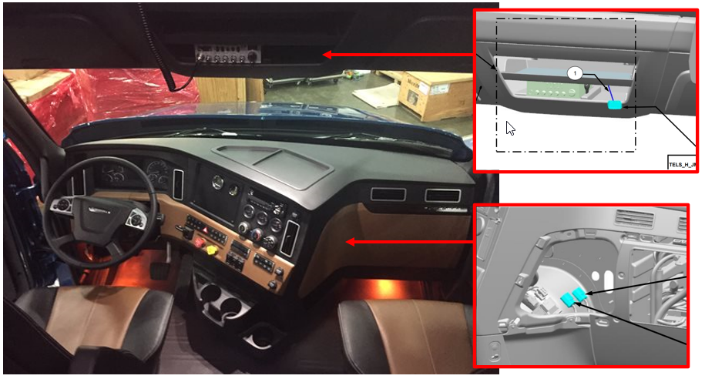

1. Record the Serial Number of the device – Please write down the serial number of the device, you will be required to enter it as an annotation in Servicenet when you finish the job.

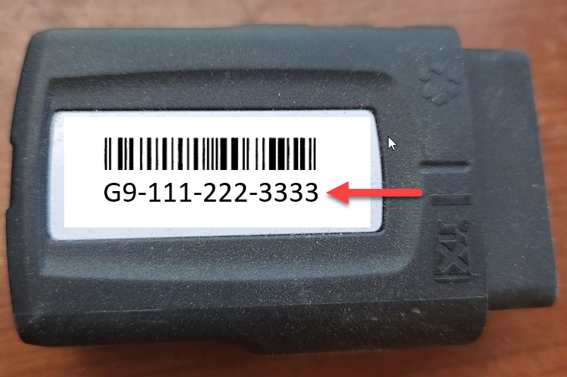

1. Install the Geotab device and harness – Attach the wiring harness to the open plug. Attach the Geotab device to the RP1226 plug on the wiring harness.

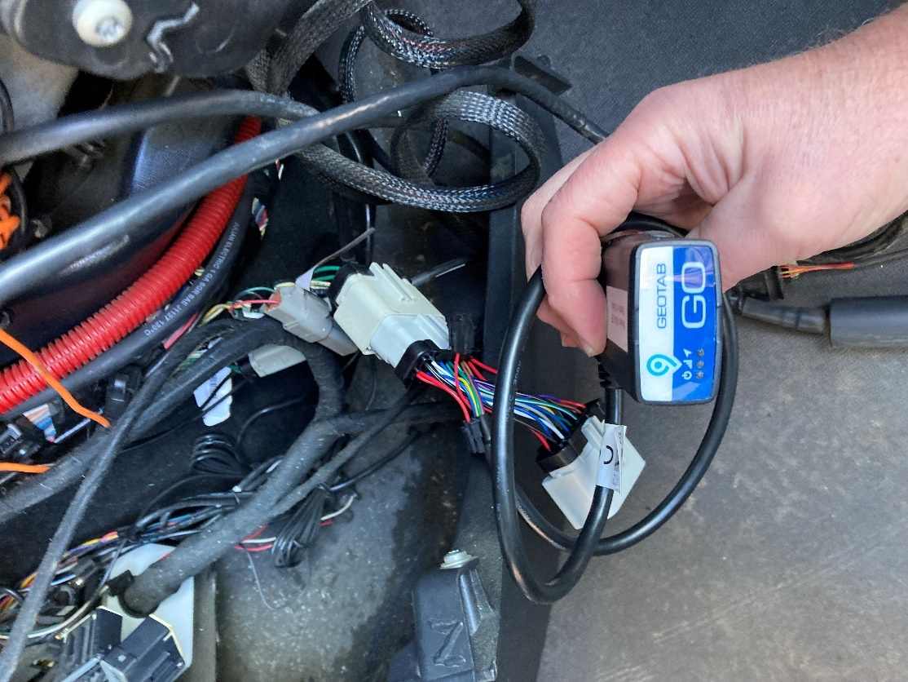

1. Check the LEDs on the device – There should be three LED lights, RED = Ignition ON, GREEN = Cellular communication, BLUE = GPS location lock. If all of the LEDs illuminate you are done and can skip to step 6.

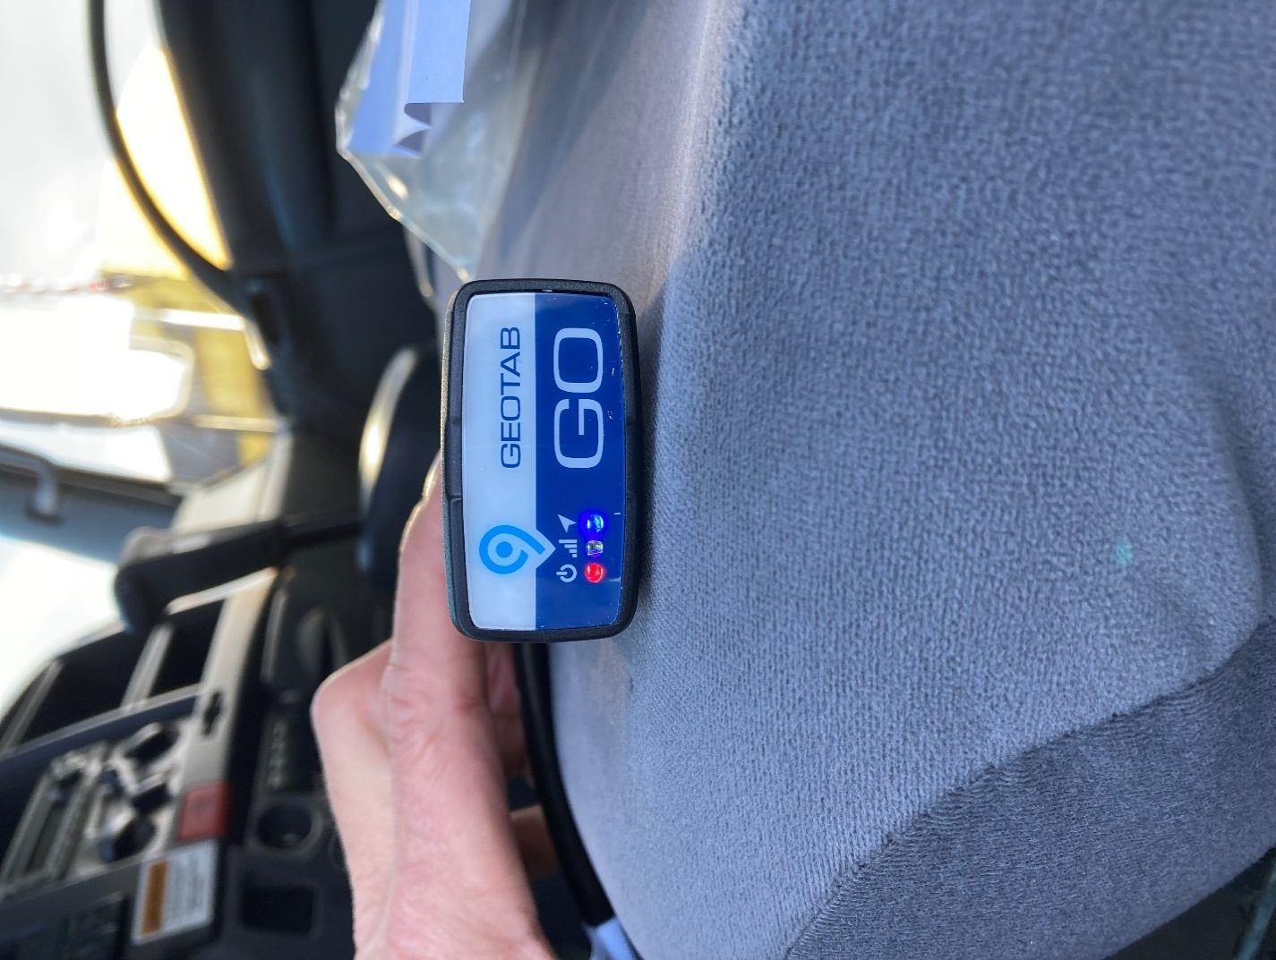

* 1. If some but not all LEDs light up, take the truck on a 5-minute drive. If all the LEDs light up, you can skip to step 6.
  2. If no LEDs are illuminated it is most likely a power problem, possibly a blown fuse. Before checking any fuses, an easy test is to place the device in another vehicle’s diagnostic port and verify if the LEDs illuminate correctly. This will identify if it is a device issue or a vehicle issue. If it is power issue, it could be any fuse.
  3. If neither a or b worked, the system needs to be replaced. Please use the spare in your inventory and install it into the harness. Please start back at Step 4 to ensure the replacement device is working.

1. Confirm the device started reporting – Go to <https://install.assuredtelematics.com/penske/> and enter in the required information.



Once submitted, you will get one of the following screens:

Success, move to step 7:



Failure, retry the troubleshooting instructions in step 5. If it appears again, replace the device with one from your inventory or use the Order Device button to order a new device:



If you get the below error while you are filling out the form, it means one of two things happened:

* 1. The device you installed in the truck is old and has been terminated and will not work. Use another device from inventory or order one by clicking on the Order Device button.
  2. The device was purchased from the wrong reseller. Please try and return that device and order one by clicking on the Order Device button.



If you have questions while troubleshooting, please contact Geotab/Assured Telematics at 720-515-3535 or [support@assuredtelematics.com](mailto:support@assuredtelematics.com).

Please dispose of any defective devices.

1. Finish the repair – Once the Geotab is confirmed to be working, please check that the Nexiq Bluetooth ELD device is still working. Then resecure the Geotab with a zip tie or Velcro tie and replace the devices where you found them. Make sure the harness is not pinched.
2. Enter Serial Number in the Annotation field – When you finish the job, Servicenet will prompt you to enter the serial number. Please make sure it is entered correctly.

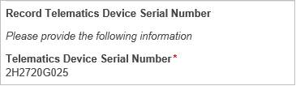

If there are any questions, please contact Penske’s Onboard Device Team at [Penske.OSMs@penske.com](mailto:Penske.OSMs@penske.com).

**Freightliner M2 (Straight Truck) Install**

1. Make sure you have a Geotab and correct Harness in stock. (Please make sure you are not trying to use a Nexiq Bluetooth ELD Device)

Geotab Device: Nexiq Bluetooth ELD Devices:

Do not work on ELD

  

1. Locate Geotab Telematic Installation Area – Geotabs should be installed on the J1939 Diagnostic port. You may find other devices, including the Nexiq Bluetooth ELD Device if the vehicle requires driver logs (this is easily identifiable if the vehicle has a sticker on the exterior or interior identifying it is logging-capable). Leave all non-Geotab devices in place.

If you see a Geotab device installed, please use the directions on page 1 to verify if it is a Penske-owned device.

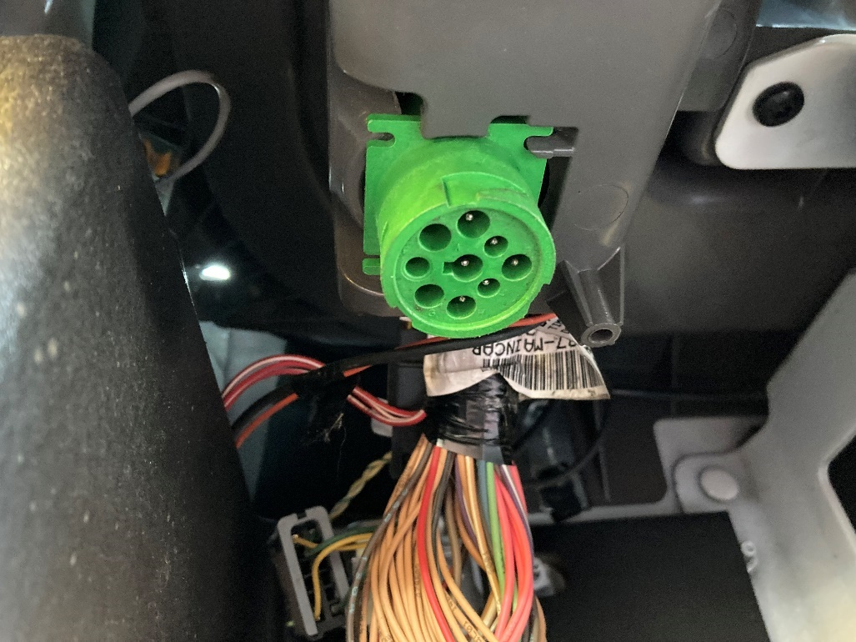

1. Record the Serial Number of the device – Please write down the serial number of the device, you will be required to enter it as an annotation in Servicenet when you finish the job.



1. Install the Geotab device and harness – Attach the wiring harness to the open plug. Attach the Geotab device to the J1939 plug on the wiring harness.

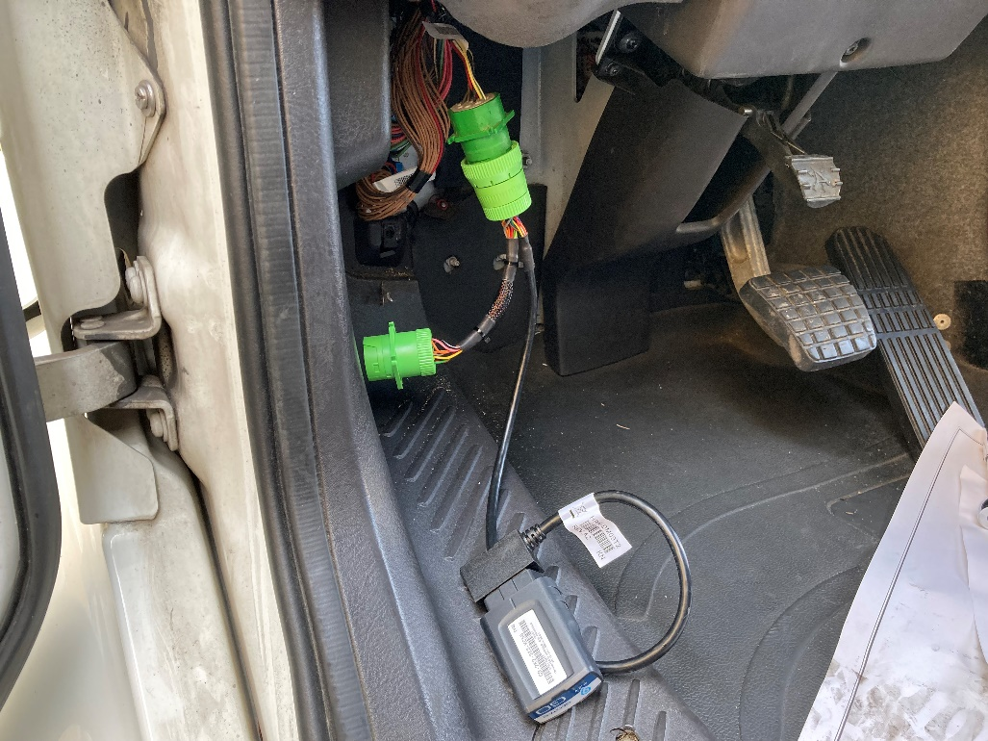

1. Check the LEDs on the device – There should be three LED lights, RED = Ignition ON, GREEN = Cellular communication, BLUE = GPS location lock. If all of the LEDs illuminate you are done and can skip to step 6.



* 1. If some but not all LEDs light up, take the truck on a 5-minute drive. If all the LEDs light up, you can skip to step 6.
  2. If no LEDs are illuminated it is most likely a power problem, possibly a blown fuse. Before checking any fuses, an easy test is to place the device in another vehicle’s diagnostic port and verify if the LEDs illuminate correctly. This will identify if it is a device issue or a vehicle issue. If it is power issue, it could be any fuse.
  3. If neither a or b worked, the system needs to be replaced. Please use the spare in your inventory and install it into the harness. Please start back at Step 4 to ensure the replacement device is working.

1. Confirm the device started reporting – Go to <https://install.assuredtelematics.com/penske/> and enter in the required information.



Once submitted, you will get one of the following screens:

Success, move to step 7:



Failure, retry the troubleshooting instructions in step 5. If it appears again, replace the device with one from your inventory or use the Order Device button to order a new device:



If you get the below error while you are filling out the form, it means one of two things happened:

* 1. The device you installed in the truck is old and has been terminated and will not work. Use another device from inventory or order one by clicking on the Order Device button.
  2. The device was purchased from the wrong reseller. Please try and return that device and order one by clicking on the Order Device button.



If you have questions while troubleshooting, please contact Geotab/Assured Telematics at 720-515-3535 or [support@assuredtelematics.com](mailto:support@assuredtelematics.com).

Please dispose of any defective devices.

1. Finish the repair – Once the Geotab is confirmed to be working, please check that the Nexiq Bluetooth ELD device is still working. Then resecure the Geotab with a zip tie or Velcro tie and replace the devices where you found them. Make sure the harness is not pinched.
2. Enter Serial Number in the Annotation field – When you finish the job, Servicenet will prompt you to enter the serial number. Please make sure it is entered correctly.



If there are any questions, please contact Penske’s Onboard Device Team at [Penske.OSMs@penske.com](mailto:Penske.OSMs@penske.com).

**Hino 100-Series (Straight Truck) Install**

1. Make sure you have a Geotab and correct Harness in stock. (Please make sure you are not trying to use a Nexiq Bluetooth ELD Device)

Geotab Device: Nexiq Bluetooth ELD Devices:

Do not work on ELD

  

1. Locate Geotab Telematic Installation Area – Geotabs should be installed on the OBD2 Diagnostic port. You may find other devices, including the Nexiq Bluetooth ELD Device if the vehicle requires driver logs (this is easily identifiable if the vehicle has a sticker on the exterior or interior identifying it is logging-capable). Leave all non-Geotab devices in place.

If you see a Geotab device installed, please use the directions on page 1 to verify if it is a Penske-owned device.

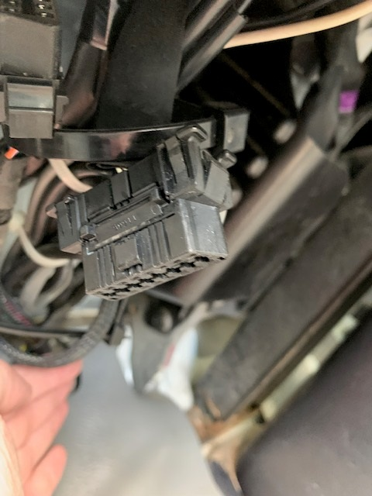

1. Record the Serial Number of the device – Please write down the serial number of the device, you will be required to enter it as an annotation in Servicenet when you finish the job.



1. Install the Geotab device and harness – Attach the wiring harness to the open plug. Attach the Geotab device to the OBD2 plug on the wiring harness.

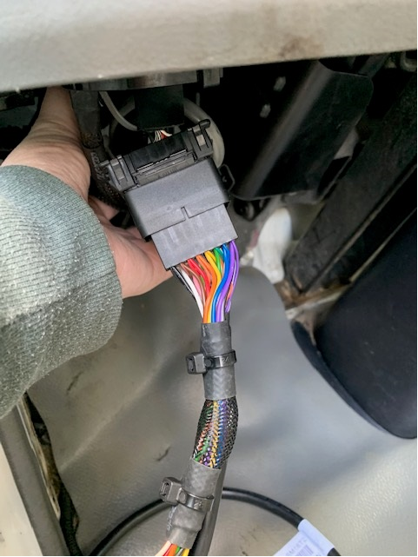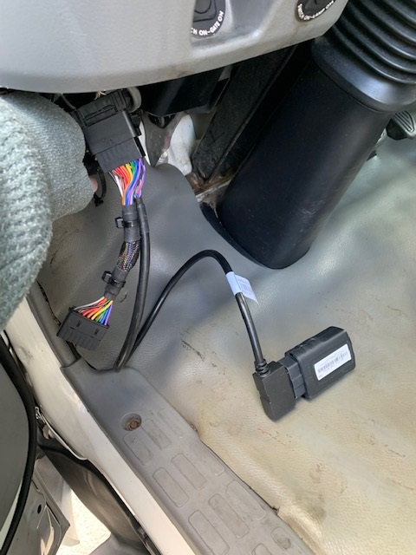

1. Check the LEDs on the device – There should be three LED lights, RED = Ignition ON, GREEN = Cellular communication, BLUE = GPS location lock. If all of the LEDs illuminate you are done and can skip to step 6.



* 1. If some but not all LEDs light up, take the truck on a 5-minute drive. If all the LEDs light up, you can skip to step 6.
  2. If no LEDs are illuminated it is most likely a power problem, possibly a blown fuse. Before checking any fuses, an easy test is to place the device in another vehicle’s diagnostic port and verify if the LEDs illuminate correctly. This will identify if it is a device issue or a vehicle issue. If it is power issue, it could be any fuse.
  3. If neither a or b worked, the system needs to be replaced. Please use the spare in your inventory and install it into the harness. Please start back at Step 4 to ensure the replacement device is working.

1. Confirm the device started reporting – Go to <https://install.assuredtelematics.com/penske/> and enter in the required information.



Once submitted, you will get one of the following screens:

Success, move to step 7:



Failure, retry the troubleshooting instructions in step 5. If it appears again, replace the device with one from your inventory or use the Order Device button to order a new device:



If you get the below error while you are filling out the form, it means one of two things happened:

* 1. The device you installed in the truck is old and has been terminated and will not work. Use another device from inventory or order one by clicking on the Order Device button.
  2. The device was purchased from the wrong reseller. Please try and return that device and order one by clicking on the Order Device button.



If you have questions while troubleshooting, please contact Geotab/Assured Telematics at 720-515-3535 or [support@assuredtelematics.com](mailto:support@assuredtelematics.com).

Please dispose of any defective devices.

1. Finish the repair – Once the Geotab is confirmed to be working, please check that the Nexiq Bluetooth ELD device is still working. Then resecure the Geotab with a zip tie or Velcro tie and replace the devices where you found them. Make sure the harness is not pinched.
2. Enter Serial Number in the Annotation field – When you finish the job, Servicenet will prompt you to enter the serial number. Please make sure it is entered correctly.



If there are any questions, please contact Penske’s Onboard Device Team at [Penske.OSMs@penske.com](mailto:Penske.OSMs@penske.com).

**Hino 200 or 300-Series (Straight Truck) Install**

1. Make sure you have a Geotab and correct Harness in stock. (Please make sure you are not trying to use a Nexiq Bluetooth ELD Device)

Geotab Device: Nexiq Bluetooth ELD Devices:

Do not work on ELD

  

1. Locate Geotab Telematic Installation Area – Geotabs should be installed on the OBD2 Diagnostic port. You may find other devices, including the Nexiq Bluetooth ELD Device if the vehicle requires driver logs (this is easily identifiable if the vehicle has a sticker on the exterior or interior identifying it is logging-capable). Leave all non-Geotab devices in place.

If you see a Geotab device installed, please use the directions on page 1 to verify if it is a Penske-owned device.

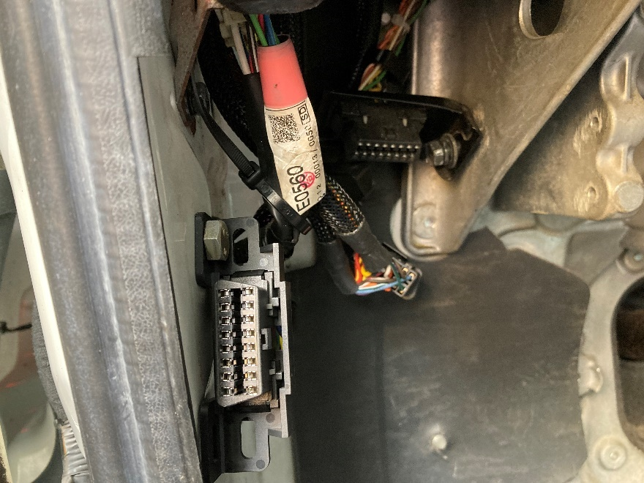

1. Record the Serial Number of the device – Please write down the serial number of the device, you will be required to enter it as an annotation in Servicenet when you finish the job.



1. Install the Geotab device and harness – Attach the wiring harness to the open plug. Attach the Geotab device to the OBD2 plug on the wiring harness.

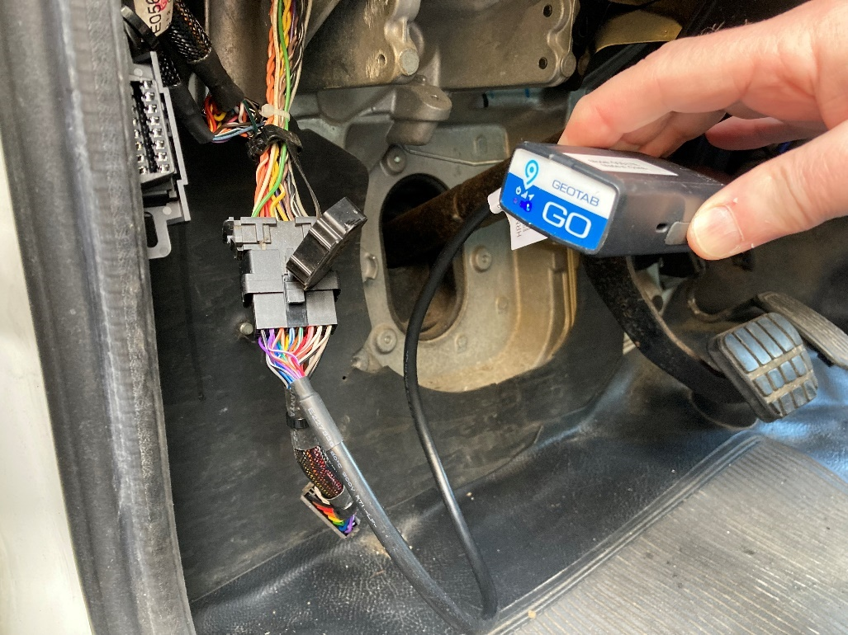

1. Check the LEDs on the device – There should be three LED lights, RED = Ignition ON, GREEN = Cellular communication, BLUE = GPS location lock. If all of the LEDs illuminate you are done and can skip to step 6.



* 1. If some but not all LEDs light up, take the truck on a 5-minute drive. If all the LEDs light up, you can skip to step 6.
  2. If no LEDs are illuminated it is most likely a power problem, possibly a blown fuse. Before checking any fuses, an easy test is to place the device in another vehicle’s diagnostic port and verify if the LEDs illuminate correctly. This will identify if it is a device issue or a vehicle issue. If it is power issue, it could be any fuse.
  3. If neither a or b worked, the system needs to be replaced. Please use the spare in your inventory and install it into the harness. Please start back at Step 4 to ensure the replacement device is working.

1. Confirm the device started reporting – Go to <https://install.assuredtelematics.com/penske/> and enter in the required information.



Once submitted, you will get one of the following screens:

Success, move to step 7:



Failure, retry the troubleshooting instructions in step 5. If it appears again, replace the device with one from your inventory or use the Order Device button to order a new device:



If you get the below error while you are filling out the form, it means one of two things happened:

* 1. The device you installed in the truck is old and has been terminated and will not work. Use another device from inventory or order one by clicking on the Order Device button.
  2. The device was purchased from the wrong reseller. Please try and return that device and order one by clicking on the Order Device button.



If you have questions while troubleshooting, please contact Geotab/Assured Telematics at 720-515-3535 or [support@assuredtelematics.com](mailto:support@assuredtelematics.com).

Please dispose of any defective devices.

1. Finish the repair – Once the Geotab is confirmed to be working, please check that the Nexiq Bluetooth ELD device is still working. Then resecure the Geotab with a zip tie or Velcro tie and replace the devices where you found them. Make sure the harness is not pinched.
2. Enter Serial Number in the Annotation field – When you finish the job, Servicenet will prompt you to enter the serial number. Please make sure it is entered correctly.



If there are any questions, please contact Penske’s Onboard Device Team at [Penske.OSMs@penske.com](mailto:Penske.OSMs@penske.com).

**International LT RP1226 Install (Preferred Installation)**

1. Make sure you have a Geotab and correct Harness in stock. (Please make sure you are not trying to use a Nexiq Bluetooth ELD Device)

Geotab Device: Nexiq Bluetooth ELD Devices:

Do not work on ELD

  

1. Locate Geotab Telematic Installation Area – Geotabs should be installed on the RP1226 port. The RP1226 connector will be located in one of three places: Middle of the dash, behind the middle cupholders, or in the middle overhead bin (see picture below). You may find other devices, including the Nexiq Bluetooth ELD Device if the vehicle requires driver logs (this is easily identifiable if the vehicle has a sticker on the exterior or interior identifying it is logging-capable). Leave all non-Geotab devices in place.

If you see a Geotab device installed, please use the directions on page 1 to verify if it is a Penske-owned device.

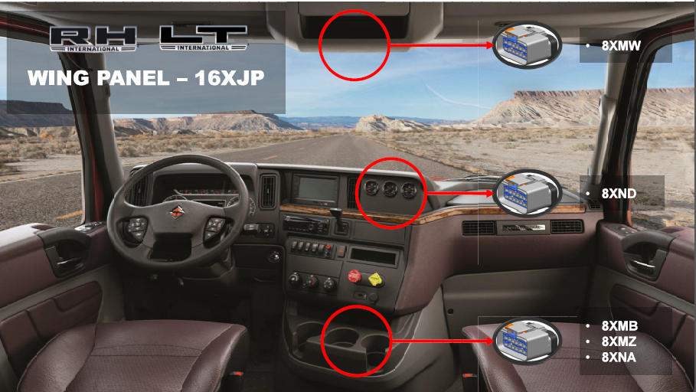

1. Record the Serial Number of the device – Please write down the serial number of the device, you will be required to enter it as an annotation in Servicenet when you finish the job.



1. Install the Geotab device and harness – Attach the wiring harness to the open plug. Attach the Geotab device to the RP1226 plug on the wiring harness.

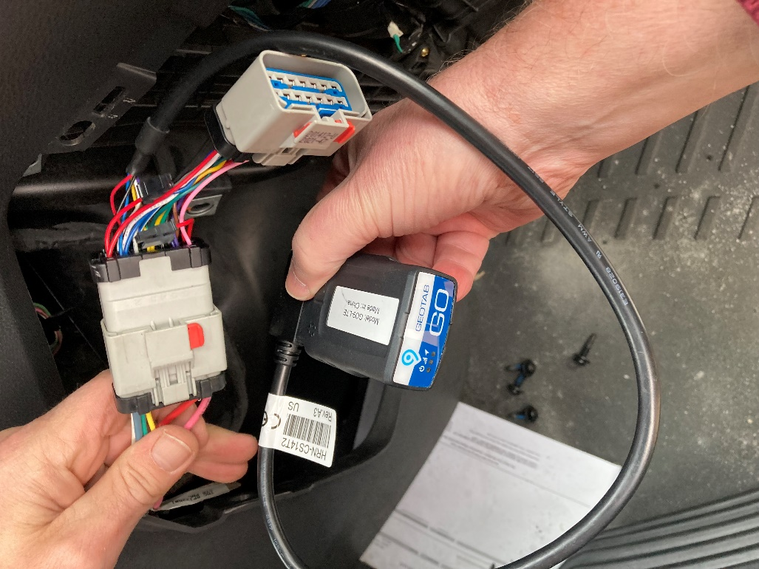

1. Check the LEDs on the device – There should be three LED lights, RED = Ignition ON, GREEN = Cellular communication, BLUE = GPS location lock. If all of the LEDs illuminate you are done and can skip to step 6.



* 1. If some but not all LEDs light up, take the truck on a 5-minute drive. If all the LEDs light up, you can skip to step 6.
  2. If no LEDs are illuminated it is most likely a power problem, possibly a blown fuse. Before checking any fuses, an easy test is to place the device in another vehicle’s diagnostic port and verify if the LEDs illuminate correctly. This will identify if it is a device issue or a vehicle issue. If it is power issue, it could be any fuse.
  3. If neither a or b worked, the system needs to be replaced. Please use the spare in your inventory and install it into the harness. Please start back at Step 4 to ensure the replacement device is working.

1. Confirm the device started reporting – Go to <https://install.assuredtelematics.com/penske/> and enter in the required information.



Once submitted, you will get one of the following screens:

Success, move to step 7:



Failure, retry the troubleshooting instructions in step 5. If it appears again, replace the device with one from your inventory or use the Order Device button to order a new device:



If you get the below error while you are filling out the form, it means one of two things happened:

* 1. The device you installed in the truck is old and has been terminated and will not work. Use another device from inventory or order one by clicking on the Order Device button.
  2. The device was purchased from the wrong reseller. Please try and return that device and order one by clicking on the Order Device button.



If you have questions while troubleshooting, please contact Geotab/Assured Telematics at 720-515-3535 or [support@assuredtelematics.com](mailto:support@assuredtelematics.com).

Please dispose of any defective devices.

1. Finish the repair – Once the Geotab is confirmed to be working, please check that the Nexiq Bluetooth ELD device is still working. Then resecure the Geotab with a zip tie or Velcro tie and replace the devices where you found them. Make sure the harness is not pinched.
2. Enter Serial Number in the Annotation field – When you finish the job, Servicenet will prompt you to enter the serial number. Please make sure it is entered correctly.



If there are any questions, please contact Penske’s Onboard Device Team at [Penske.OSMs@penske.com](mailto:Penske.OSMs@penske.com).

**International 4300 (Straight Truck) Install**

1. Make sure you have a Geotab and correct Harness in stock. (Please make sure you are not trying to use a Nexiq Bluetooth ELD Device)

Geotab Device: Nexiq Bluetooth ELD Devices:

Do not work on ELD

  

1. Locate Geotab Telematic Installation Area – Geotabs should be installed on the J1939 Diagnostic port. You may find other devices, including the Nexiq Bluetooth ELD Device if the vehicle requires driver logs (this is easily identifiable if the vehicle has a sticker on the exterior or interior identifying it is logging-capable). Leave all non-Geotab devices in place.

If you see a Geotab device installed, please use the directions on page 1 to verify if it is a Penske-owned device.

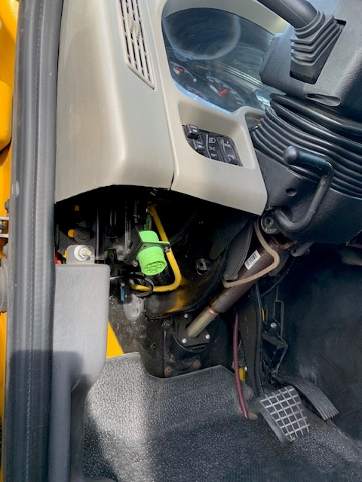

1. Record the Serial Number of the device – Please write down the serial number of the device, you will be required to enter it as an annotation in Servicenet when you finish the job.



1. Install the Geotab device and harness – Attach the wiring harness to the open plug. Attach the Geotab device to the J1939 plug on the wiring harness.

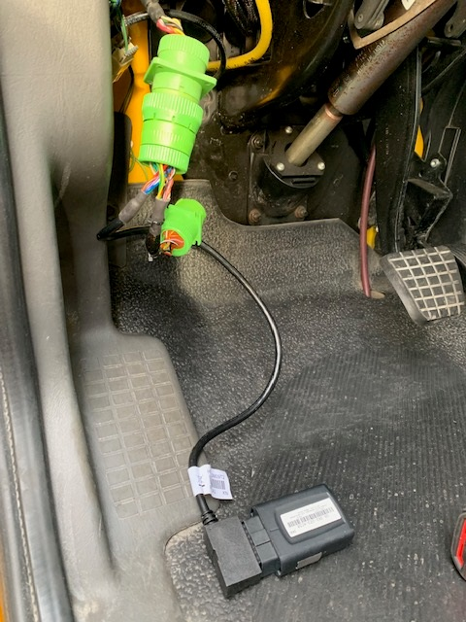

1. Check the LEDs on the device – There should be three LED lights, RED = Ignition ON, GREEN = Cellular communication, BLUE = GPS location lock. If all of the LEDs illuminate you are done and can skip to step 6.



* 1. If some but not all LEDs light up, take the truck on a 5-minute drive. If all the LEDs light up, you can skip to step 6.
  2. If no LEDs are illuminated it is most likely a power problem, possibly a blown fuse. Before checking any fuses, an easy test is to place the device in another vehicle’s diagnostic port and verify if the LEDs illuminate correctly. This will identify if it is a device issue or a vehicle issue. If it is power issue, it could be any fuse.
  3. If neither a or b worked, the system needs to be replaced. Please use the spare in your inventory and install it into the harness. Please start back at Step 4 to ensure the replacement device is working.

1. Confirm the device started reporting – Go to <https://install.assuredtelematics.com/penske/> and enter in the required information.



Once submitted, you will get one of the following screens:

Success, move to step 7:



Failure, retry the troubleshooting instructions in step 5. If it appears again, replace the device with one from your inventory or use the Order Device button to order a new device:



If you get the below error while you are filling out the form, it means one of two things happened:

* 1. The device you installed in the truck is old and has been terminated and will not work. Use another device from inventory or order one by clicking on the Order Device button.
  2. The device was purchased from the wrong reseller. Please try and return that device and order one by clicking on the Order Device button.



If you have questions while troubleshooting, please contact Geotab/Assured Telematics at 720-515-3535 or [support@assuredtelematics.com](mailto:support@assuredtelematics.com).

Please dispose of any defective devices.

1. Finish the repair – Once the Geotab is confirmed to be working, please check that the Nexiq Bluetooth ELD device is still working. Then resecure the Geotab with a zip tie or Velcro tie and replace the devices where you found them. Make sure the harness is not pinched.
2. Enter Serial Number in the Annotation field – When you finish the job, Servicenet will prompt you to enter the serial number. Please make sure it is entered correctly.



If there are any questions, please contact Penske’s Onboard Device Team at [Penske.OSMs@penske.com](mailto:Penske.OSMs@penske.com).

**International MV607 (Straight Truck) Install**

1. Make sure you have a Geotab and correct Harness in stock. (Please make sure you are not trying to use a Nexiq Bluetooth ELD Device)

Geotab Device: Nexiq Bluetooth ELD Devices:

Do not work on ELD

  

1. Locate Geotab Telematic Installation Area – Geotabs should be installed on the RP1226 port. The RP1226 port is located in the center of the dash and can be found behind the panels marked A and B below. You may find other devices, including the Nexiq Bluetooth ELD Device if the vehicle requires driver logs (this is easily identifiable if the vehicle has a sticker on the exterior or interior identifying it is logging-capable). Leave all non-Geotab devices in place.

If you see a Geotab device installed, please use the directions on page 1 to verify if it is a Penske-owned device.

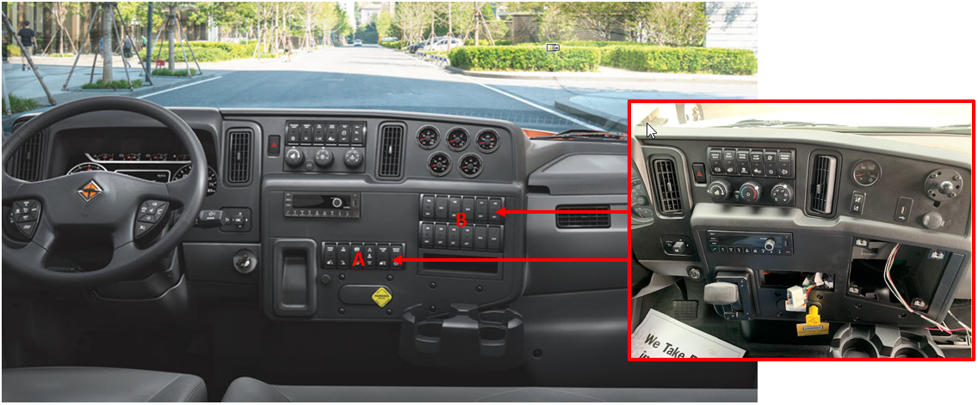

1. Record the Serial Number of the device – Please write down the serial number of the device, you will be required to enter it as an annotation in Servicenet when you finish the job.



1. Install the Geotab device and harness – Attach the wiring harness to the open plug. Attach the Geotab device to the RP1226 plug on the wiring harness.

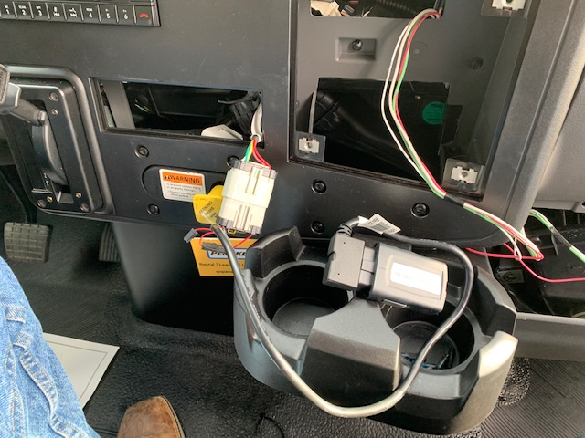

1. Check the LEDs on the device – There should be three LED lights, RED = Ignition ON, GREEN = Cellular communication, BLUE = GPS location lock. If all of the LEDs illuminate you are done and can skip to step 6.



* 1. If some but not all LEDs light up, take the truck on a 5-minute drive. If all the LEDs light up, you can skip to step 6.
  2. If no LEDs are illuminated it is most likely a power problem, possibly a blown fuse. Before checking any fuses, an easy test is to place the device in another vehicle’s diagnostic port and verify if the LEDs illuminate correctly. This will identify if it is a device issue or a vehicle issue. If it is power issue, it could be any fuse.
  3. If neither a or b worked, the system needs to be replaced. Please use the spare in your inventory and install it into the harness. Please start back at Step 4 to ensure the replacement device is working.

1. Confirm the device started reporting – Go to <https://install.assuredtelematics.com/penske/> and enter in the required information.



Once submitted, you will get one of the following screens:

Success, move to step 7:



Failure, retry the troubleshooting instructions in step 5. If it appears again, replace the device with one from your inventory or use the Order Device button to order a new device:



If you get the below error while you are filling out the form, it means one of two things happened:

* 1. The device you installed in the truck is old and has been terminated and will not work. Use another device from inventory or order one by clicking on the Order Device button.
  2. The device was purchased from the wrong reseller. Please try and return that device and order one by clicking on the Order Device button.



If you have questions while troubleshooting, please contact Geotab/Assured Telematics at 720-515-3535 or [support@assuredtelematics.com](mailto:support@assuredtelematics.com).

Please dispose of any defective devices.

1. Finish the repair – Once the Geotab is confirmed to be working, please check that the Nexiq Bluetooth ELD device is still working. Then resecure the Geotab with a zip tie or Velcro tie and replace the devices where you found them. Make sure the harness is not pinched.
2. Enter Serial Number in the Annotation field – When you finish the job, Servicenet will prompt you to enter the serial number. Please make sure it is entered correctly.



If there are any questions, please contact Penske’s Onboard Device Team at [Penske.OSMs@penske.com](mailto:Penske.OSMs@penske.com).

**Isuzu NPR**

1. Make sure you have a Geotab and correct Harness in stock. (Please make sure you are not trying to use a Nexiq Bluetooth ELD Device)

Geotab Device: Nexiq Bluetooth ELD Devices:

Do not work on ELD

  

1. Locate Geotab Telematic Installation Area – Geotabs should be installed on the diagnostic port. Open that area (most likely the kick panel) and detach the diagnostic port. You may find other devices, including the Nexiq Bluetooth ELD Device if the vehicle requires driver logs (this is easily identifiable if the vehicle has a sticker on the exterior or interior identifying it is logging-capable). Leave all non-Geotab devices in place.

If you see a Geotab device installed, please use the directions on page 1 to verify if it is a Penske-owned device.

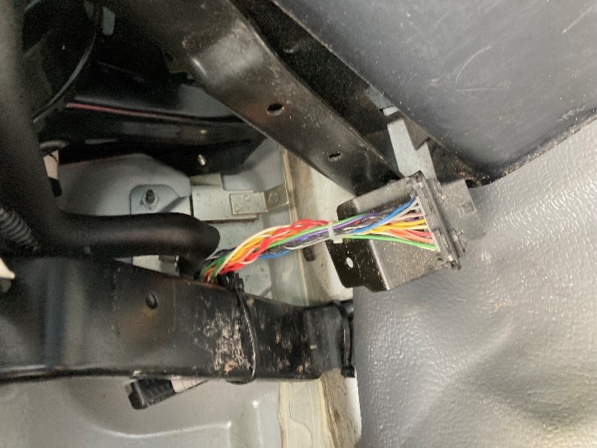

1. Record the Serial Number of the device – Please write down the serial number of the device, you will be required to enter it as an annotation in Servicenet when you finish the job.



1. Install the Geotab device and harness – Attach the wiring harness to the open plug. Attach the Geotab device to the OBD2 plug on the wiring harness.

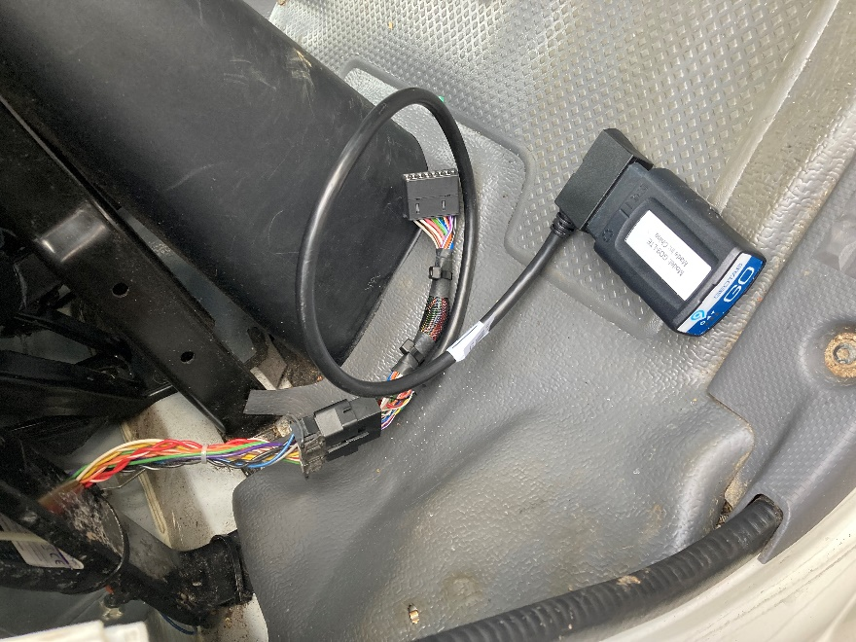

1. Check the LEDs on the device – There should be three LED lights, RED = Ignition ON, GREEN = Cellular communication, BLUE = GPS location lock. If all of the LEDs illuminate you are done and can skip to step 6.



* 1. If some but not all LEDs light up, take the truck on a 5-minute drive. If all the LEDs light up, you can skip to step 6.
  2. If no LEDs are illuminated it is most likely a power problem, possibly a blown fuse. Before checking any fuses, an easy test is to place the device in another vehicle’s diagnostic port and verify if the LEDs illuminate correctly. This will identify if it is a device issue or a vehicle issue. If it is power issue, it could be any fuse.
  3. If neither a or b worked, the system needs to be replaced. Please use the spare in your inventory and install it into the harness. Please start back at Step 4 to ensure the replacement device is working.

1. Confirm the device started reporting – Go to <https://install.assuredtelematics.com/penske_isuzu/> and enter in the required information. It is important to fill in the odometer setting correctly.

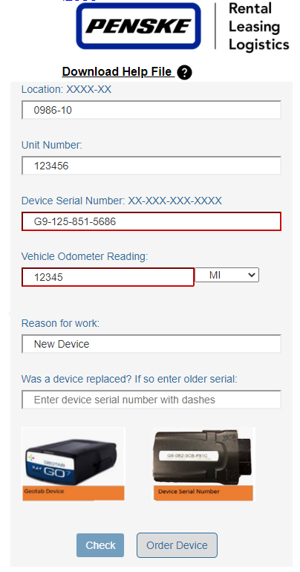

Once submitted, you will get one of the following screens:

Success, move to step 7:



Failure, retry the troubleshooting instructions in step 5. If it appears again, replace the device with one from your inventory or use the Order Device button to order a new device:



If you get the below error while you are filling out the form, it means one of two things happened:

* 1. The device you installed in the truck is old and has been terminated and will not work. Use another device from inventory or order one by clicking on the Order Device button.
  2. The device was purchased from the wrong reseller. Please try and return that device and order one by clicking on the Order Device button.

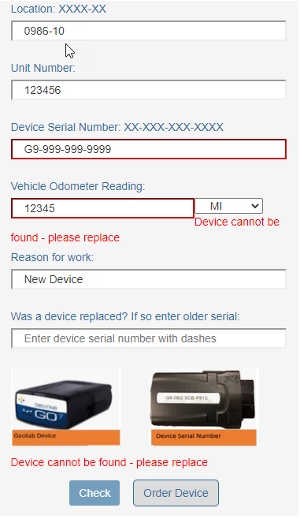

If you have questions while troubleshooting, please contact Geotab/Assured Telematics at 720-515-3535 or [support@assuredtelematics.com](mailto:support@assuredtelematics.com).

Please dispose of any defective devices.

1. Finish the repair – Once the Geotab is confirmed to be working, please check that the Nexiq Bluetooth ELD device is still working. Then resecure the Geotab with a zip tie or Velcro tie and replace the devices where you found them. Make sure the harness is not pinched.
2. Enter Serial Number in the Annotation field – When you finish the job, Servicenet will prompt you to enter the serial number. Please make sure it is entered correctly.



If there are any questions, please contact Penske’s Onboard Device Team at [Penske.OSMs@penske.com](mailto:Penske.OSMs@penske.com).

**Volvo VNL Install**

1. Make sure you have a Geotab and correct Harness in stock. (Please make sure you are not trying to use a Nexiq Bluetooth ELD Device)

Geotab Device: Nexiq Bluetooth ELD Devices:

Do not work on ELD

  

1. Locate Geotab Telematic Installation Area – Geotabs should be installed on the RP1226 port. The RP1226 port is located in the center of the dash and can be found under the indicated panel. The connector may have moved below the fuse panel, so if you don’t see it, losen the fuse panel and look under it. You may find other devices, including the Nexiq Bluetooth ELD Device if the vehicle requires driver logs (this is easily identifiable if the vehicle has a sticker on the exterior or interior identifying it is logging-capable). Leave all non-Geotab devices in place.

If you see a Geotab device installed, please use the directions on page 1 to verify if it is a Penske-owned device.

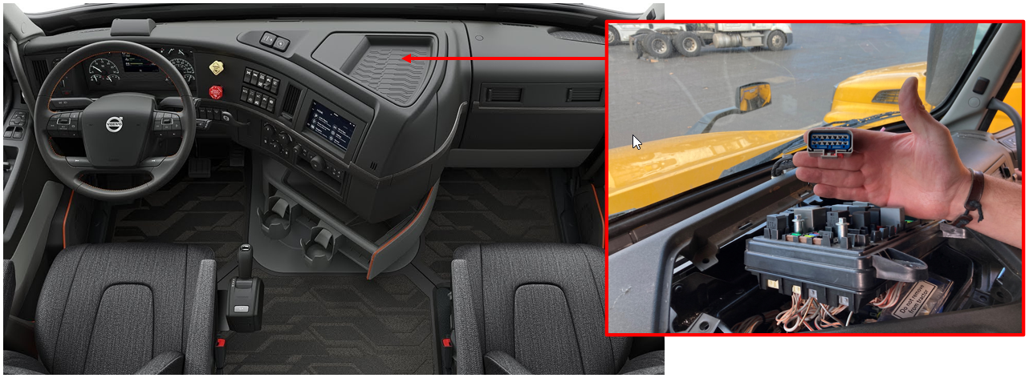

1. Record the Serial Number of the device – Please write down the serial number of the device, you will be required to enter it as an annotation in Servicenet when you finish the job.



1. Install the Geotab device and harness – Attach the wiring harness to the open plug. Attach the Geotab device to the RP1226 plug on the wiring harness.

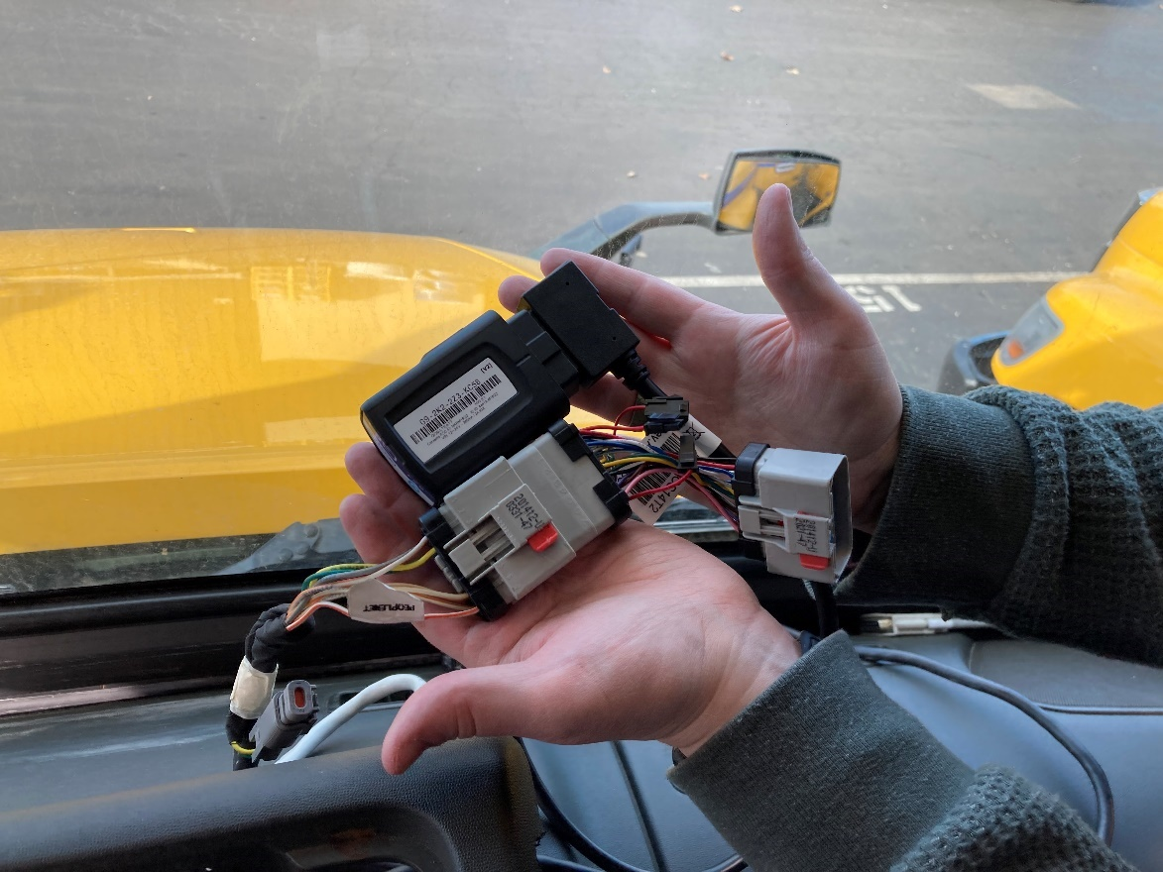

1. Check the LEDs on the device – There should be three LED lights, RED = Ignition ON, GREEN = Cellular communication, BLUE = GPS location lock. If all of the LEDs illuminate you are done and can skip to step 6.



* 1. If some but not all LEDs light up, take the truck on a 5-minute drive. If all the LEDs light up, you can skip to step 6.
  2. If no LEDs are illuminated it is most likely a power problem, possibly a blown fuse. Before checking any fuses, an easy test is to place the device in another vehicle’s diagnostic port and verify if the LEDs illuminate correctly. This will identify if it is a device issue or a vehicle issue. If it is power issue, it could be any fuse.
  3. If neither a or b worked, the system needs to be replaced. Please use the spare in your inventory and install it into the harness. Please start back at Step 4 to ensure the replacement device is working.

1. Confirm the device started reporting – Go to <https://install.assuredtelematics.com/penske/> and enter in the required information.



Once submitted, you will get one of the following screens:

Success, move to step 7:



Failure, retry the troubleshooting instructions in step 5. If it appears again, replace the device with one from your inventory or use the Order Device button to order a new device:



If you get the below error while you are filling out the form, it means one of two things happened:

* 1. The device you installed in the truck is old and has been terminated and will not work. Use another device from inventory or order one by clicking on the Order Device button.
  2. The device was purchased from the wrong reseller. Please try and return that device and order one by clicking on the Order Device button.



If you have questions while troubleshooting, please contact Geotab/Assured Telematics at 720-515-3535 or [support@assuredtelematics.com](mailto:support@assuredtelematics.com).

Please dispose of any defective devices.

1. Finish the repair – Once the Geotab is confirmed to be working, please check that the Nexiq Bluetooth ELD device is still working. Then resecure the Geotab with a zip tie or Velcro tie and replace the devices where you found them. Make sure the harness is not pinched.
2. Enter Serial Number in the Annotation field – When you finish the job, Servicenet will prompt you to enter the serial number. Please make sure it is entered correctly.



If there are any questions, please contact Penske’s Onboard Device Team at [Penske.OSMs@penske.com](mailto:Penske.OSMs@penske.com).

**GMC Savana**

1. Make sure you have a Geotab and correct Harness in stock. (Please make sure you are not trying to use a Nexiq Bluetooth ELD Device)

Geotab Device: Nexiq Bluetooth ELD Devices:

Do not work on ELD

  

1. Locate Geotab Telematic Installation Area – Geotabs should be installed on the OBD2 port. The OBD2 port is located on the driver’s side section of the dash, normally to the left of the parking brake release. You may find other devices, including the Nexiq Bluetooth ELD Device if the vehicle requires driver logs (this is easily identifiable if the vehicle has a sticker on the exterior or interior identifying it is logging-capable). Leave all non-Geotab devices in place.

If you see a Geotab device installed, please use the directions on page 1 to verify if it is a Penske-owned device.

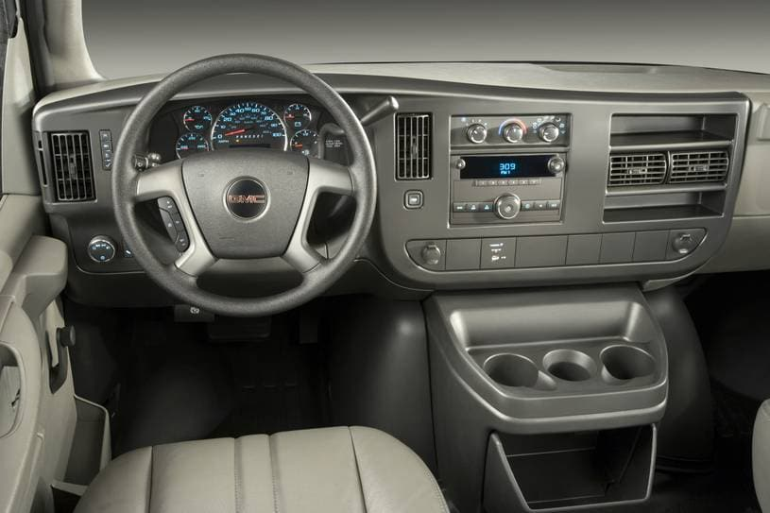

1. Record the Serial Number of the device – Please write down the serial number of the device, you will be required to enter it as an annotation in Servicenet when you finish the job.



1. Install the Geotab device and harness – Attach the wiring harness to the open plug. Attach the Geotab device to the OBD2 plug on the wiring harness.
2. Check the LEDs on the device – There should be three LED lights, RED = Ignition ON, GREEN = Cellular communication, BLUE = GPS location lock. If all of the LEDs illuminate you are done and can skip to step 6.



* 1. If some but not all LEDs light up, take the truck on a 5-minute drive. If all the LEDs light up, you can skip to step 6.
  2. If no LEDs are illuminated it is most likely a power problem, possibly a blown fuse. Before checking any fuses, an easy test is to place the device in another vehicle’s diagnostic port and verify if the LEDs illuminate correctly. This will identify if it is a device issue or a vehicle issue. If it is power issue, it could be any fuse.
  3. If neither a or b worked, the system needs to be replaced. Please use the spare in your inventory and install it into the harness. Please start back at Step 4 to ensure the replacement device is working.

1. Confirm the device started reporting – Go to <https://install.assuredtelematics.com/penske/> and enter in the required information.



Once submitted, you will get one of the following screens:

Success, move to step 7:



Failure, retry the troubleshooting instructions in step 5. If it appears again, replace the device with one from your inventory or use the Order Device button to order a new device:



If you get the below error while you are filling out the form, it means one of two things happened:

* 1. The device you installed in the truck is old and has been terminated and will not work. Use another device from inventory or order one by clicking on the Order Device button.
  2. The device was purchased from the wrong reseller. Please try and return that device and order one by clicking on the Order Device button.



If you have questions while troubleshooting, please contact Geotab/Assured Telematics at 720-515-3535 or [support@assuredtelematics.com](mailto:support@assuredtelematics.com).

Please dispose of any defective devices.

1. Finish the repair – Once the Geotab is confirmed to be working, please check that the Nexiq Bluetooth ELD device is still working. Then resecure the Geotab with a zip tie or Velcro tie and replace the devices where you found them. Make sure the harness is not pinched.
2. Enter Serial Number in the Annotation field – When you finish the job, Servicenet will prompt you to enter the serial number. Please make sure it is entered correctly.



If there are any questions, please contact Penske’s Onboard Device Team at [Penske.OSMs@penske.com](mailto:Penske.OSMs@penske.com).

**Ford E350**

1. Make sure you have a Geotab and correct Harness in stock. (Please make sure you are not trying to use a Nexiq Bluetooth ELD Device)

Geotab Device: Nexiq Bluetooth ELD Devices:

Do not work on ELD

  

1. Locate Geotab Telematic Installation Area – Geotabs should be installed on the OBD2 port. The OBD2 port is located on the driver’s side section of the dash, normally to the left of the parking brake release. You may find other devices, including the Nexiq Bluetooth ELD Device if the vehicle requires driver logs (this is easily identifiable if the vehicle has a sticker on the exterior or interior identifying it is logging-capable). Leave all non-Geotab devices in place.

If you see a Geotab device installed, please use the directions on page 1 to verify if it is a Penske-owned device.

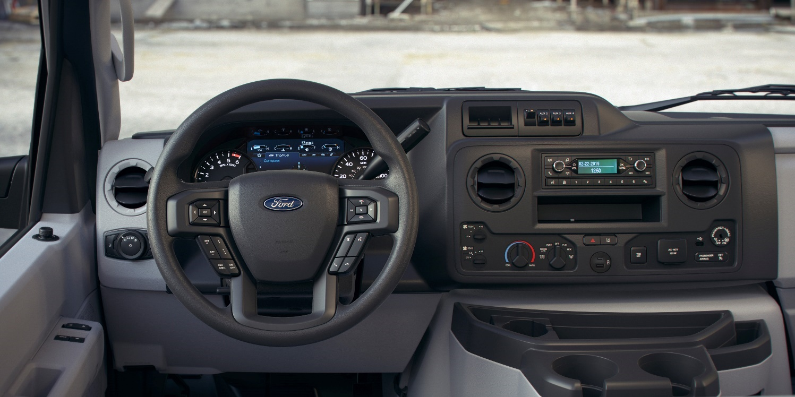

1. Record the Serial Number of the device – Please write down the serial number of the device, you will be required to enter it as an annotation in Servicenet when you finish the job.



1. Install the Geotab device and harness – Attach the wiring harness to the open plug. Attach the Geotab device to the OBD2 plug on the wiring harness.
2. Check the LEDs on the device – There should be three LED lights, RED = Ignition ON, GREEN = Cellular communication, BLUE = GPS location lock. If all of the LEDs illuminate you are done and can skip to step 6.



* 1. If some but not all LEDs light up, take the truck on a 5-minute drive. If all the LEDs light up, you can skip to step 6.
  2. If no LEDs are illuminated it is most likely a power problem, possibly a blown fuse. Before checking any fuses, an easy test is to place the device in another vehicle’s diagnostic port and verify if the LEDs illuminate correctly. This will identify if it is a device issue or a vehicle issue. If it is power issue, it could be any fuse.
  3. If neither a or b worked, the system needs to be replaced. Please use the spare in your inventory and install it into the harness. Please start back at Step 4 to ensure the replacement device is working.

1. Confirm the device started reporting – Go to <https://install.assuredtelematics.com/penske/> and enter in the required information.



Once submitted, you will get one of the following screens:

Success, move to step 7:



Failure, retry the troubleshooting instructions in step 5. If it appears again, replace the device with one from your inventory or use the Order Device button to order a new device:



If you get the below error while you are filling out the form, it means one of two things happened:

* 1. The device you installed in the truck is old and has been terminated and will not work. Use another device from inventory or order one by clicking on the Order Device button.
  2. The device was purchased from the wrong reseller. Please try and return that device and order one by clicking on the Order Device button.



If you have questions while troubleshooting, please contact Geotab/Assured Telematics at 720-515-3535 or [support@assuredtelematics.com](mailto:support@assuredtelematics.com).

Please dispose of any defective devices.

1. Finish the repair – Once the Geotab is confirmed to be working, please check that the Nexiq Bluetooth ELD device is still working. Then resecure the Geotab with a zip tie or Velcro tie and replace the devices where you found them. Make sure the harness is not pinched.
2. Enter Serial Number in the Annotation field – When you finish the job, Servicenet will prompt you to enter the serial number. Please make sure it is entered correctly.



If there are any questions, please contact Penske’s Onboard Device Team at [Penske.OSMs@penske.com](mailto:Penske.OSMs@penske.com).

**Ford Transit**

1. Make sure you have a Geotab and correct Harness in stock. (Please make sure you are not trying to use a Nexiq Bluetooth ELD Device)

Geotab Device: Nexiq Bluetooth ELD Devices:

Do not work on ELD

  

1. Locate Geotab Telematic Installation Area – Geotabs should be installed on the OBD2 port. The OBD2 port is located on the driver’s side section of the dash, normally to the left of the parking brake release. It does help to remover the panel below the steering wheel for easier access to the install area. You may find other devices, including the Nexiq Bluetooth ELD Device if the vehicle requires driver logs (this is easily identifiable if the vehicle has a sticker on the exterior or interior identifying it is logging-capable). Leave all non-Geotab devices in place.

If you see a Geotab device installed, please use the directions on page 1 to verify if it is a Penske-owned device.

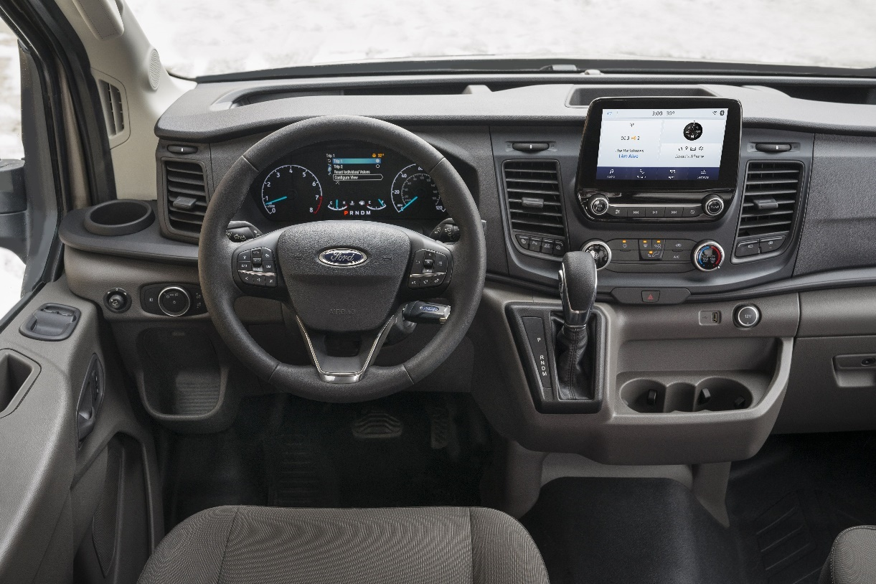

1. Record the Serial Number of the device – Please write down the serial number of the device, you will be required to enter it as an annotation in Servicenet when you finish the job.



1. Install the Geotab device and harness – Attach the wiring harness to the open plug. Attach the Geotab device to the OBD2 plug on the wiring harness.
2. Check the LEDs on the device – There should be three LED lights, RED = Ignition ON, GREEN = Cellular communication, BLUE = GPS location lock. If all of the LEDs illuminate you are done and can skip to step 6.



* 1. If some but not all LEDs light up, take the truck on a 5-minute drive. If all the LEDs light up, you can skip to step 6.
  2. If no LEDs are illuminated it is most likely a power problem, possibly a blown fuse. Before checking any fuses, an easy test is to place the device in another vehicle’s diagnostic port and verify if the LEDs illuminate correctly. This will identify if it is a device issue or a vehicle issue. If it is power issue, it could be any fuse.
  3. If neither a or b worked, the system needs to be replaced. Please use the spare in your inventory and install it into the harness. Please start back at Step 4 to ensure the replacement device is working.

1. Confirm the device started reporting – Go to <https://install.assuredtelematics.com/penske/> and enter in the required information.



Once submitted, you will get one of the following screens:

Success, move to step 7:



Failure, retry the troubleshooting instructions in step 5. If it appears again, replace the device with one from your inventory or use the Order Device button to order a new device:



If you get the below error while you are filling out the form, it means one of two things happened:

* 1. The device you installed in the truck is old and has been terminated and will not work. Use another device from inventory or order one by clicking on the Order Device button.
  2. The device was purchased from the wrong reseller. Please try and return that device and order one by clicking on the Order Device button.



If you have questions while troubleshooting, please contact Geotab/Assured Telematics at 720-515-3535 or [support@assuredtelematics.com](mailto:support@assuredtelematics.com).

Please dispose of any defective devices.

1. Finish the repair – Once the Geotab is confirmed to be working, please check that the Nexiq Bluetooth ELD device is still working. Then resecure the Geotab with a zip tie or Velcro tie and replace the devices where you found them. Make sure the harness is not pinched.
2. Enter Serial Number in the Annotation field – When you finish the job, Servicenet will prompt you to enter the serial number. Please make sure it is entered correctly.



If there are any questions, please contact Penske’s Onboard Device Team at [Penske.OSMs@penske.com](mailto:Penske.OSMs@penske.com).

**Dodge ProMaster**

1. Make sure you have a Geotab and correct Harness in stock. (Please make sure you are not trying to use a Nexiq Bluetooth ELD Device)

Geotab Device: Nexiq Bluetooth ELD Devices:

Do not work on ELD

  

1. Locate Geotab Telematic Installation Area – Geotabs should be installed on the OBD2 port. The OBD2 port is located on the driver’s side section of the dash, normally to the left of the parking brake release. It does help to remover the panel below the steering wheel for easier access to the install area. You may find other devices, including the Nexiq Bluetooth ELD Device if the vehicle requires driver logs (this is easily identifiable if the vehicle has a sticker on the exterior or interior identifying it is logging-capable). Leave all non-Geotab devices in place.

If you see a Geotab device installed, please use the directions on page 1 to verify if it is a Penske-owned device.

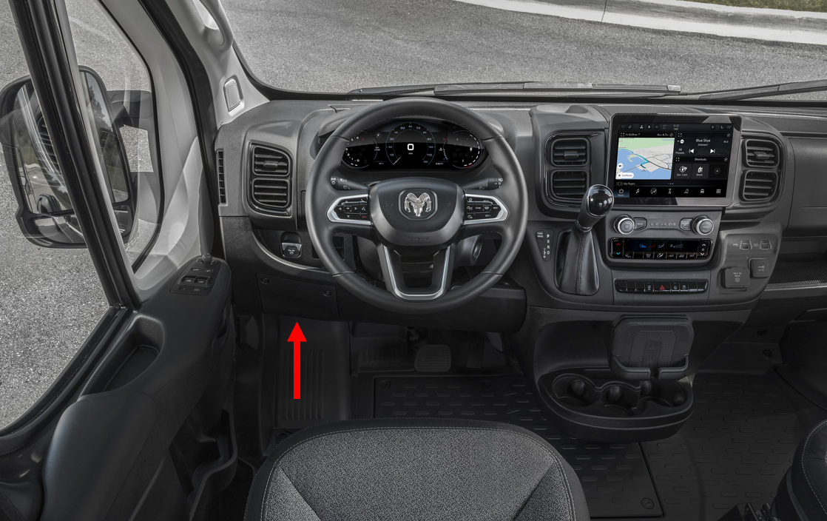

1. Record the Serial Number of the device – Please write down the serial number of the device, you will be required to enter it as an annotation in Servicenet when you finish the job.



1. Install the Geotab device and harness – Attach the wiring harness to the open plug. Attach the Geotab device to the OBD2 plug on the wiring harness.
2. Check the LEDs on the device – There should be three LED lights, RED = Ignition ON, GREEN = Cellular communication, BLUE = GPS location lock. If all of the LEDs illuminate you are done and can skip to step 6.



* 1. If some but not all LEDs light up, take the truck on a 5-minute drive. If all the LEDs light up, you can skip to step 6.
  2. If no LEDs are illuminated it is most likely a power problem, possibly a blown fuse. Before checking any fuses, an easy test is to place the device in another vehicle’s diagnostic port and verify if the LEDs illuminate correctly. This will identify if it is a device issue or a vehicle issue. If it is power issue, it could be any fuse.
  3. If neither a or b worked, the system needs to be replaced. Please use the spare in your inventory and install it into the harness. Please start back at Step 4 to ensure the replacement device is working.

1. Confirm the device started reporting – Go to <https://install.assuredtelematics.com/penske/> and enter in the required information.



Once submitted, you will get one of the following screens:

Success, move to step 7:



Failure, retry the troubleshooting instructions in step 5. If it appears again, replace the device with one from your inventory or use the Order Device button to order a new device:



If you get the below error while you are filling out the form, it means one of two things happened:

* 1. The device you installed in the truck is old and has been terminated and will not work. Use another device from inventory or order one by clicking on the Order Device button.
  2. The device was purchased from the wrong reseller. Please try and return that device and order one by clicking on the Order Device button.



If you have questions while troubleshooting, please contact Geotab/Assured Telematics at 720-515-3535 or [support@assuredtelematics.com](mailto:support@assuredtelematics.com).

Please dispose of any defective devices.

1. Finish the repair – Once the Geotab is confirmed to be working, please check that the Nexiq Bluetooth ELD device is still working. Then resecure the Geotab with a zip tie or Velcro tie and replace the devices where you found them. Make sure the harness is not pinched.
2. Enter Serial Number in the Annotation field – When you finish the job, Servicenet will prompt you to enter the serial number. Please make sure it is entered correctly.



If there are any questions, please contact Penske’s Onboard Device Team at [Penske.OSMs@penske.com](mailto:Penske.OSMs@penske.com).